LAB PROGRAMS
Day 3- 09/01/2026
Name: R Prashanth Naik
Register Number: 192472272
Course: CSA0412-Fundamentals of Data Science for Data Analytics

Experiment 11
import pandas as pd
import matplotlib.pyplot as plt
df = pd.read_csv("sales_data_sample.csv", encoding="latin1")
df["ORDERDATE"] = pd.to_datetime(df["ORDERDATE"])
df["Month"] = df["ORDERDATE"].dt.strftime("%b %Y")
monthly_sales = df.groupby("Month")["SALES"].sum()

plt.figure()
plt.plot(monthly_sales.index, monthly_sales.values)
plt.xlabel("Month")
plt.ylabel("Sales")
plt.title("Monthly Sales Line Plot")
plt.xticks(rotation=45)
plt.tight_layout()
plt.show()

plt.figure()
plt.scatter(monthly_sales.index, monthly_sales.values)
plt.xlabel("Month")
plt.ylabel("Sales")
plt.title("Monthly Sales Scatter Plot")
plt.xticks(rotation=45)
plt.tight_layout()
plt.show()

plt.figure()
plt.bar(monthly_sales.index, monthly_sales.values)
plt.xlabel("Month")
plt.ylabel("Sales")
plt.title("Monthly Sales Bar Plot")
plt.xticks(rotation=45)
plt.tight_layout()
plt.show()

Output:
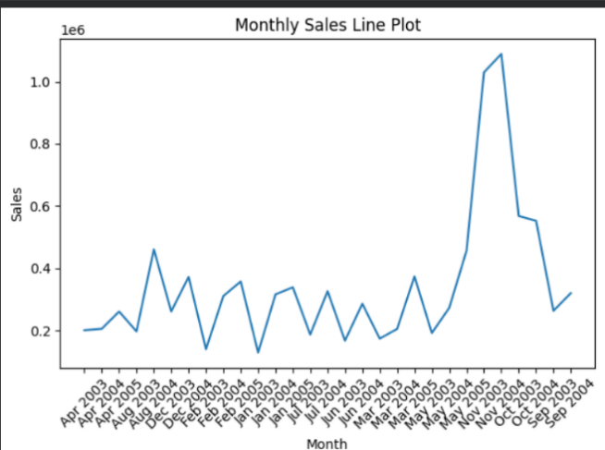
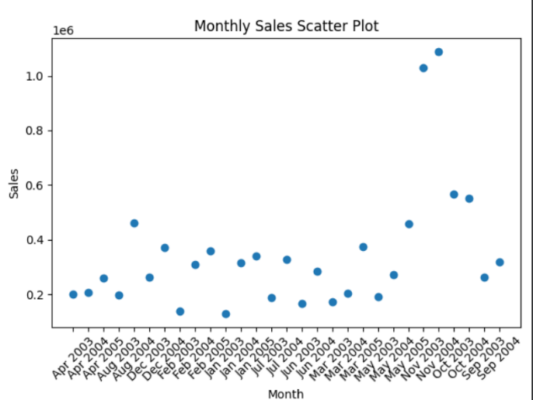

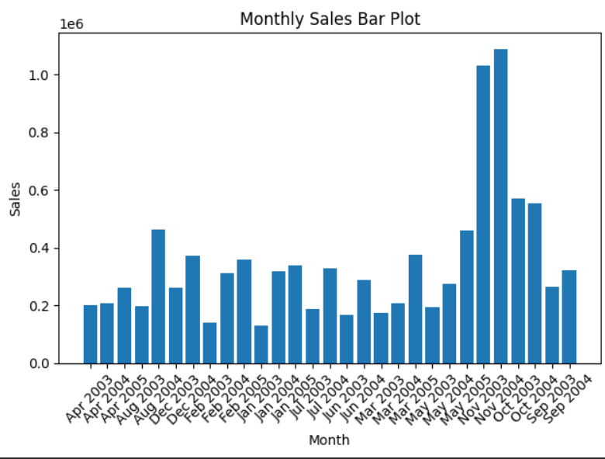

Experiment 12
Program:
import pandas as pd
import matplotlib.pyplot as plt
data = pd.read_csv("monthly_weather_data.csv")
year_data = data[data["Year"] == 2022]
months = year_data["Month"]
temperature = year_data["Temperature_C"]
rainfall = year_data["Rainfall_mm"]
plt.figure()
plt.plot(months, temperature)
plt.xlabel("Month")
plt.ylabel("Temperature (°C)")
plt.title("Monthly Temperature Data (2022)")
plt.show()
plt.figure()
plt.scatter(months, rainfall)
plt.xlabel("Month")
plt.ylabel("Rainfall (mm)")
plt.title("Monthly Rainfall Data (2022)")
plt.show()
Output:
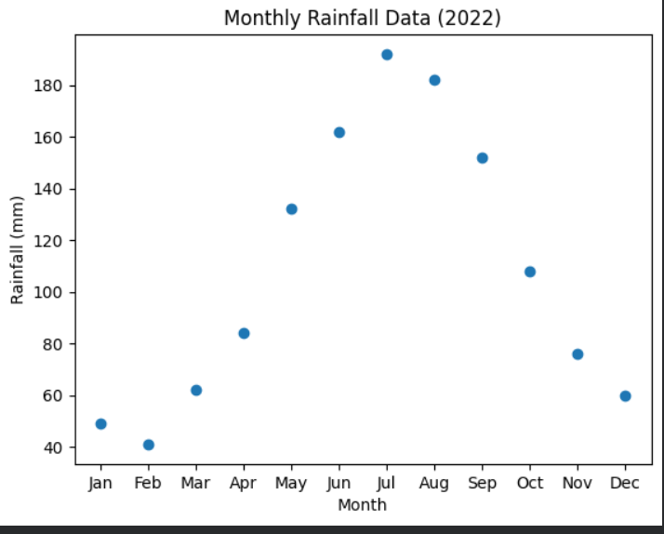
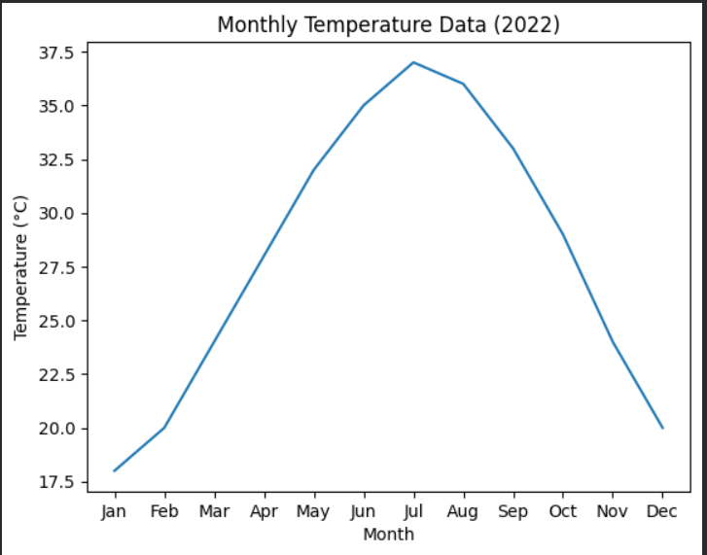

Experiment 13
Program:
import pandas as pd
from collections import Counter
import string
df = pd.read_csv("sample_text.csv")
text = " ".join(df["text"]).lower()
text = text.translate(str.maketrans("", "", string.punctuation))
words = text.split()
word_frequency = Counter(words)
print("Word Frequency Distribution:")
for word, count in word_frequency.items():
print(word, ":", count)

Output:
Word Frequency Distribution:
data : 18
science : 5
is : 7
an : 3
interdisciplinary : 1
field : 1
that : 1
uses : 1
scientific : 1
methods : 1
processes : 1
algorithms : 2
and : 14
systems : 1
to : 6
extract : 1
knowledge : 1
from : 2
machine : 5
learning : 5
a : 3
core : 1
part : 1
of : 4
enables : 1
computers : 1
learn : 1
python : 3
one : 1
the : 1
most : 1
popular : 1
programming : 1
languages : 1
for : 4
analysis : 8
involves : 1
cleaning : 1
processing : 2
visualizing : 1
gain : 1
useful : 1
insights : 2
big : 2
technologies : 1
help : 1
organizations : 1
store : 1
analyze : 2
large : 2
volumes : 1
text : 5
important : 2
application : 1
natural : 1
language : 1
used : 5
such : 2
as : 2
reviews : 1
social : 1
media : 1
posts : 1
word : 2
frequency : 2
basic : 1
technique : 1
in : 4
mining : 2
many : 1
companies : 2
use : 1
improve : 2
decision : 2
making : 2
business : 1
strategies : 1
are : 3
prediction : 1
classification : 1
clustering : 1
tasks : 1
provides : 1
libraries : 1
numpy : 1
pandas : 1
matplotlib : 1
can : 1
be : 1
structured : 1
or : 1
unstructured : 1
requires : 1
preprocessing : 1
before : 1
scientists : 1
often : 1
work : 1
with : 1
datasets : 1
discover : 1
patterns : 1
trends : 1
artificial : 1
intelligence : 1
closely : 1
related : 1
fields : 1
visualization : 1
helps : 3
present : 1
understandable : 1
way : 1
techniques : 1
widely : 2
sentiment : 1
customer : 1
feedback : 1
products : 1
services : 1
analytics : 1
supports : 1
real : 1
time : 1
automation : 1
distribution : 1
identify : 1
terms : 1
document : 1

Experiment 14
Program:
import pandas as pd
df = pd.read_csv("ecommerce_customer_behaviour.csv")
df.columns = df.columns.str.strip()
past_month_data = df[df["Days Since Last Purchase"] <= 30]
age_frequency = past_month_data["Age"].value_counts().sort_index()
print("Frequency distribution of customer ages (past month):")
print(age_frequency)

Output:
Frequency distribution of customer ages (past month):
Age
27 1
28 24
29 10
30 48
31 19
32 9
33 10
34 24
35 25
36 25
37 22
38 9
Name: count, dtype: int64

Experiment 15
Program:
import pandas as pd
data = pd.read_csv("post_likes.csv")
likes_frequency = data["Likes"].value_counts()
print("Frequency distribution of likes among posts:")
print(likes_frequency)

Output:
Frequency distribution of likes among posts:
Likes
25 4
40 4
60 3
80 3
100 3
120 2
140 1
Name: count, dtype: int64

